2024 YORKSHIRE YOUNG ACHIEVERS AWARDS  ADVERT BOOKING FORM  Gala Dinner & Awards Presentation  THURSDAY 14 NOVEMBER 2024 AT THE CENTENARY PAVILION, ELLAND ROAD |  | 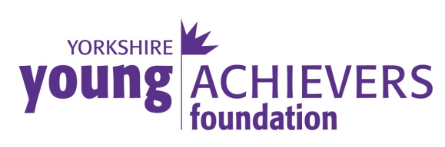  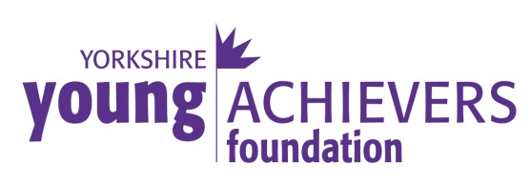
The Yorkshire Young Achievers Awards were established in order to recognise and reward outstanding achievement by young people in or from Yorkshire. Anyone can make a nomination and anyone can be a winner, as long as they meet the requirements.

The winners are decided by a panel of senior members of the Yorkshire community representing different walks of life and Awards are presented at the Gala Dinner.

The Awards, given in the following categories, are open to anyone who was born, lives or works in Yorkshire and is under the age of 35.

AWARD CATEGORIES:
Personality of the Year
Sponsored by Rudding Park

Youngster of the Year (12 & under)
Sponsored by Nabarro McAllister

Unsung Hero
Sponsored by Jamboree Entertainment Ltd

Achievement in Sport
Sponsored by Leeds United AFC

Achievement in the Arts
Sponsored by Mary and Jeremy Carter

Achievement in Education
Sponsored by Harrogate Town A.F.C.

Achievement in Management & Enterprise
Sponsored by CHR Group

Special Award
Sponsored by GMI Property

If you have someone to nominate please visit our website or call Sonia Jones on 01423 530630 for a nomination form. Closing date is Friday 23 August 2024

Name
Company
Email
Postal Address
Postcode
Telephone No

Please reserve me the following space……

The Awards Programme is an A5 publication with a circulation of approximately 450

 | Half page A6 Landscape Advert @ £175
 | Full Page A5 Portrait Advert @ £300
 | Full Page A5 Portrait Advert (inside back cover) £400*
* subject to availability

◻ I enclose a cheque for £__________ made payable to “The Yorkshire
Young Achievers Foundation”
◻ Please send me an invoice

Please return your form to: Sonia Jones by email to s.jones@mccormicks-solicitors.com or if enclosing a cheque please send to: Yorkshire Young Achievers Foundation, First Floor, Scottsdale House, Springfield Avenue, Harrogate, HG1 2HR.

Invoices are payable within 14 days of receipt.

Make a DONATION…..

Alternatively, if you would like to make a donation to support the work of the Yorkshire Young Achievers Foundation then please send it to Sonia Jones at the address above. All donations will be acknowledged in the Awards Programme so please let us know if you wish your donation to remain confidential.

To find out more about the Foundation please visit the website  www.yorkshireyoungachievers.co.uk  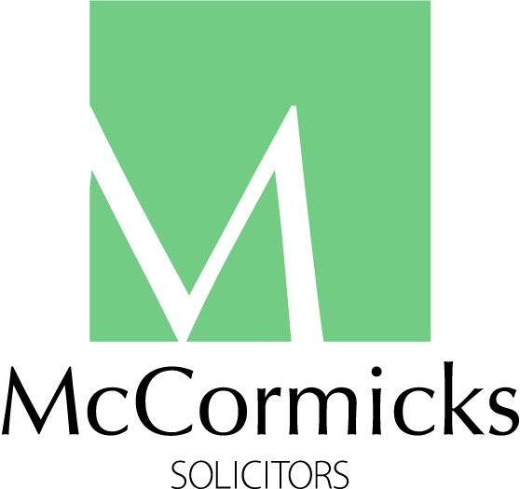 |  | Main Sponsor of the Yorkshire Young Achievers Awards
Trustees: Peter McCormick OBE (Chairman) • Nicola Corp • Jan Fletcher OBE • Sonia Jones • Charlotte McCormick • Dipesh Mistry • Fiona Robinson • Regan Seminaro • Richard Stroud MBE (Vice-Chairman) • Zoe Webber
First Floor, Scottsdale House, Springfield Avenue, Harrogate, HG1 2HR. T: 01423 530630. E: info@yorkshireyoungachievers.co.uk. Registered in England Charity No: 1135221. Registered in England Company No: 07161510.

